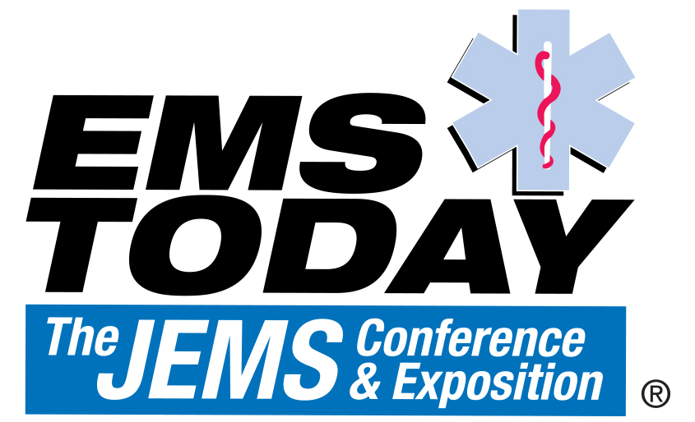 March 10 - 13, 2021 - San Antonio, Texas - USA

Disclosure of Commercial Support

Having an interest or affiliation with a corporate organization does not prevent a speaker from presenting, but the relationship must be made known in advance to the audience in accordance with the Standards of the Accreditation Council for Continuing Medical Education.

Faculty Name:

PLEASE CIRCLE or BOLD/UNDERLINE ONLY ONE:

(No)

I do not have any financial interest/arrangements or affiliations with any of the corporate
organizations offering financial support or educational grants for this program.

----------------------------------------------------------------------------------------------------------

(Yes)

I have financial interest/arrangements or affiliations with one or more of the corporate
organizations offering financial support or educational grants for this program as follows:

Affiliation/Financial Interest:

__ Grant/Research Support
__ Consultant
__ Speaker's Bureau
__ Major Stock Shareholder
__ Other Financial or Material Interest

___________________________________________________ ___________________
Signature Date

