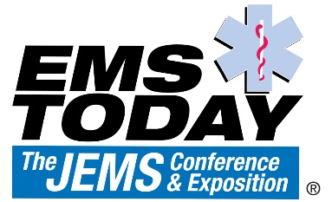
SPEAKER AGREEMENT

This Speaker Agreement (the "Agreement") is made and entered by and between ____________________ (insert person or company name), on behalf of itself and any designated speakers identified individually in attachments to this Agreement (collectively referred to as "Contributor") and Clarion/UX ("Clarion/UX"). This Agreement outlines the terms and conditions governing Contributor's speaking at EMS Today (the "Event") and the content of Contributor's presentation, including conference presentation files and other materials related thereto (the "Work").

WHEREAS, Clarion/UX has given Contributor the opportunity to speak and present the Work at the Event; and

WHEREAS, Contributor recognizes the value in such opportunity; and

WHEREAS, in consideration of such opportunity, Clarion/UX requires that Contributor allow Clarion/UX to include the Work in Clarion/UX's conference proceedings;

NOW, THEREFORE, in consideration of the mutual premises and promises set forth above and below, Clarion/UX and Contributor agree as follows:

Contributor represents and warrants that Contributor is the sole and exclusive owner of the Work or otherwise has the rights to present the Work (orally, in print, and electronically) and to grant additional rights in the Work to Clarion/UX. Contributor further represents and warrants that the Work does not now and will not infringe on one or more patents, copyrights, trademarks, or other intellectual property rights (including trade secrets), privacy, or other rights of any person or entity and does not contain any libelous, slanderous, unlawful, or objectionable material and is in compliance with all laws, statutes, orders, rules, and regulations applicable to such Work. Contributor will defend, indemnify, and hold Clarion/UX, its employees, shareholders, directors, officers, representatives, and agents harmless against any suit, action, damages, and other liability arising out of any claim based on breach of the above representations.

Contributor authorizes Clarion/UX to (i) reproduce, record in audio and/or video, reformat, and redistribute derivative parts of the Work in all languages and in all media of expression now known or later developed, including but not limited to printed conference proceedings and electronic formats such as CD-ROM, diskette, direct online access to a website or database that includes the Work, or any other form or format in which the Work may exist, for purposes of marketing EMS Today and/or other Clarion/UX publications and/or conferences; (ii) use the work to prepare compilations of the conference proceedings and/or derivative works from the Work; and (iii) display the Work publicly. Contributor retains ownership of the Work and all other copyright and intellectual property rights associated with the Work. Contributor grants Clarion/UX the right to use his/her name, image, and likeness in connection with the Work and the Event.

By signing below, Contributor agrees to receive email communications from Clarion/UX regarding the Work and/or the Event.
If you have any questions, please contact Sara Jones, Conference Coordinator, via email at Sara.Jones@clarionevents.com or telephone 918-831-9738.

AGREED AND ACCEPTED BY:
____________________________ Clarion/UX
(Company name)
on behalf of itself and each of its designated speakers
By: _________________________ By: 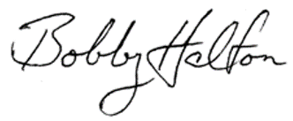
Name: Name: Bobby Halton
Credentials: Company: EMS Today
Title: Date: August 4, 2020
Company
Email:
Phone:
Date:

SUBMIT FORM TO
Sara Jones, Conference Coordinator
Email: sara.jones@clarionevents.com

