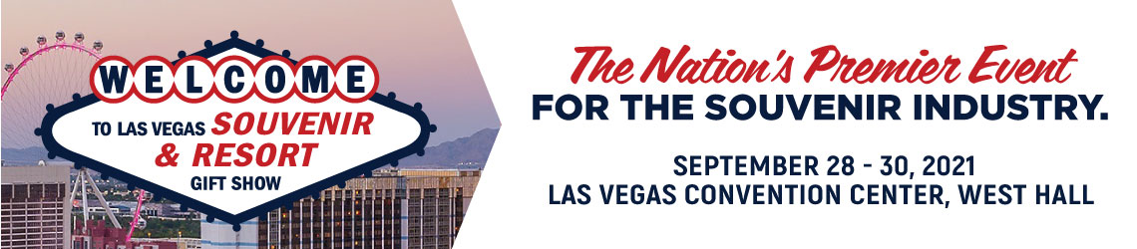

CERTIFICATE OF INSURANCE & EAC POLICY

Certificate of Insurance
A requirement of exhibiting at Las Vegas Souvenir & Resort Gift Show 2021 is for ALL exhibitors to carry liability insurance throughout the Exhibition. The deadline for submitting the Certificate indicating adequate insurance coverage is September 1, 2021. Even if Exhibitor hires an EAC, Exhibitor still must supply its own Certificate of Liability Insurance. ALL EAC’s must submit an application form with a certificate of insurance prior to deadline to be approved by show management. Exhibitor's insurance carrier must issue such Certificate of Liability Insurance. A sample insurance form can be found in the exhibitor manual.

To ensure that the Certificate of Liability Insurance has the correct information required, please make sure your certificate includes the following information.

AMOUNT SUGGESTED: One (1) Million Dollars
Under the Certificate Holder, please include:
Clarion Events, Inc. / Las Vegas Souvenir & Resort Gift Show 2021
6 Research Drive, Shelton, CT 06484

Under Description of Operations, please include:
All activities related to Las Vegas Souvenir & Resort Gift Show, September 28-30, 2021
Las Vegas Convention Center
Las Vegas, Nevada, USA

Complete Certificates of Liability Insurance must be uploaded to the exhibitor portal. Certificates of Liability Insurance will not be accepted via email or mail. Please click here to access your exhibitor portal. Your company password to access the portal can be found in your confirmation letter. Please contact your Exhibit Services Managers at ana-alyse.castelluccio@clarionevents.com or Breanna.pitts@clarionevents.com with any questions.

If you do not have insurance, or you would rather not use your own insurance, (similar to when you rent a car – so that claims would not be filed against your policy), we have set up a program with Rainprotection Insurance through which, you can purchase compliant insurance instantly online for only $84. Please click here for more information.

Exhibitor Appointed Contractors (EAC) An Exhibitor Appointed Contractor (EAC) is a company (other than the official service contractor listed in the Exhibitor Manual) that provides a service (for example, display and installation/dismantling of a booth) at Exhibitor's request and needs access to Exhibitor's booth during the installation and/or dismantling period. If you hire an EAC, you must complete and return the Request for Set Up by Non-Official Contractor Form (EAC) in Fern’s portion of the manual. The EAC will also have to provide a Certificate of Liability Insurance as described above.

Any questions related to the Certificates of Liability Insurance or an EAC should be directed to your Exhibit Services Managers at ana-alyse.castelluccio@clarionevents.com or Breanna.pitts@clarionevents.com

